Music Rudiments Name_________________________________
Worksheet 4.1 – Intro to Chords

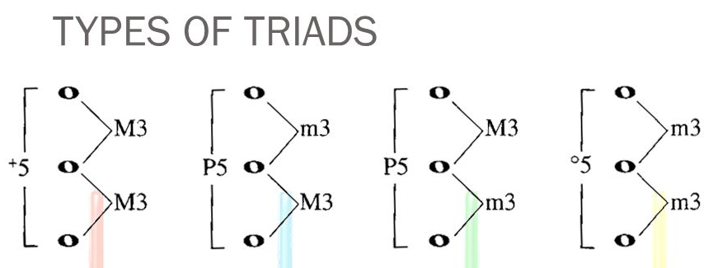
Augmented Major Minor Diminished
Triads built on C, F, and G will be major if accidentals match. Triads built on B will be diminished. The rest will come out minor.

- Identify the quality of the following chords. (M, m, d, A)
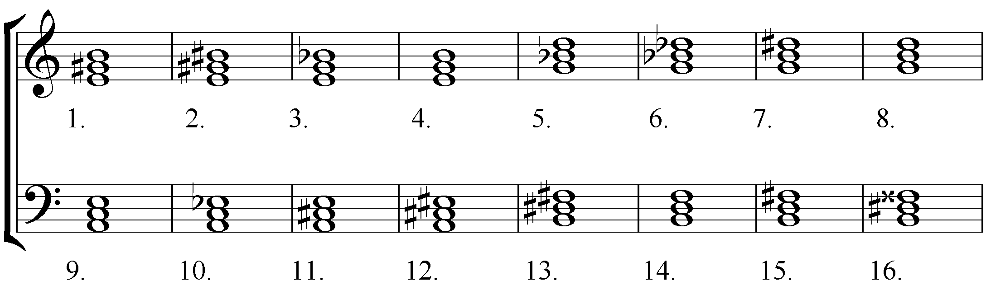

- Fill in the notes to create the designated chord quality.
