Music Rudiments Name___________________________
Worksheet 2.4
Introducing chromatic notes

Identify each key signature.
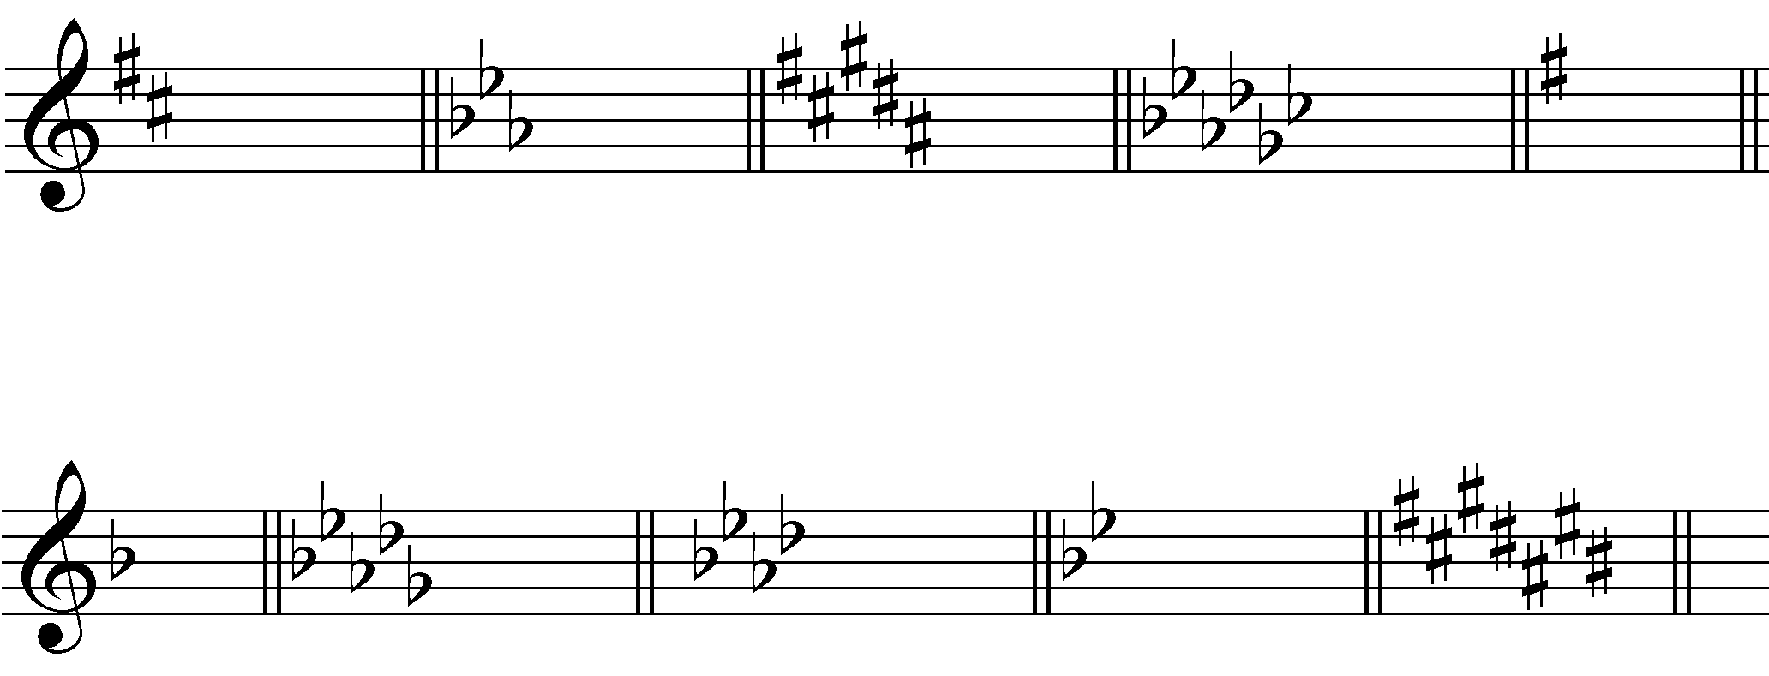

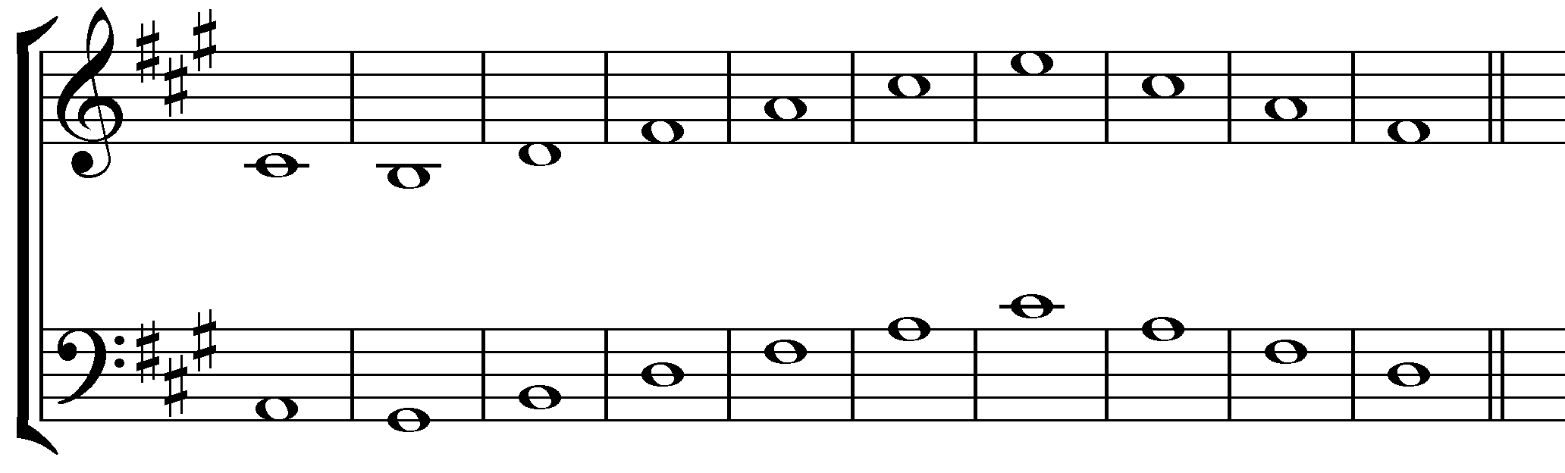
Identify each note using solfege.

Add accidentals to raise the pitch of each of the following notes ½ step. Give the new solfege name.
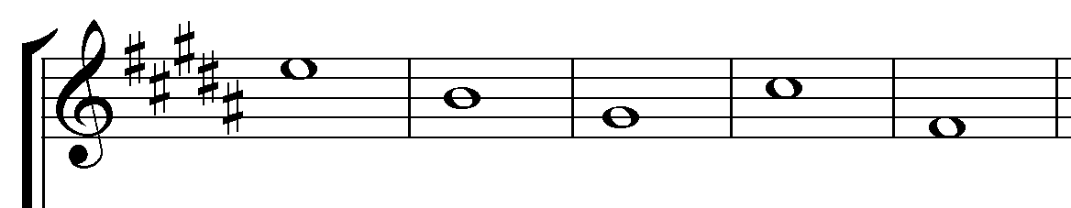

Add accidentals to lower the pitch of each of the following notes ½ step. Give the new solfege name.
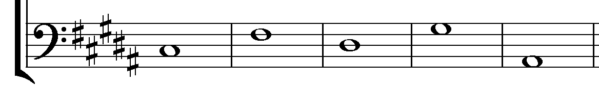

Add accidentals to raise the pitch of each of the following notes ½ step. Give the new solfege name.
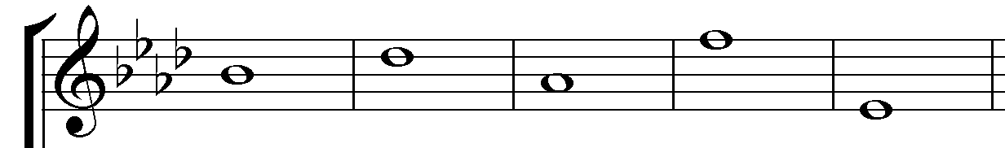

Add accidentals to lower the pitch of each of the following notes ½ step. Give the new solfege name.
