Music Rudiments Name___________________________
Worksheet 1.6

- In each box, fill in the value each note given the time signature indicated at the top of each column.
 | 4  4 | 2  2





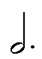




- Rewrite each figure in a simpler way. For a – c, place count under each note.
  - 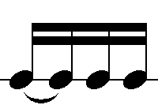
  - 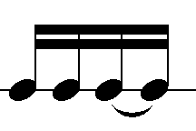
  - 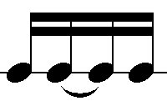
  - 

- Place correct count under each note. For notes longer than one beat, you only need to write the count of the beat on which the note starts. Counts on rests should be put in parenthesis.
