Music Rudiments Name_________________________
Worksheet 1.4

- Place bar lines.

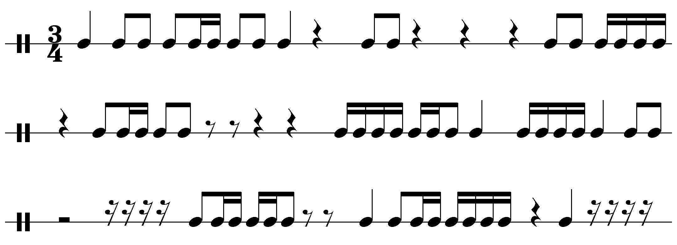

- If the quarter note is worth 1, give the value of the following notes.

- = ______
- = ______
- 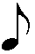= ______
- 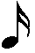= ______
- = ______

f. 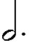= ______
g.  =______
h. =______
i. =______

- Rewrite the following examples using one dotted note or rest for each.

  -  

