Music Rudiments Name____________________________________________
Worksheet 1.2

- Draw a treble clef on the staff. Then draw the notes indicated on the pitches indicated. Do not use ledger lines. If note is above the middle line the stem should go down from the left side of the note. If note is below the middle line the stem should go up from the right side of the note. Stem length should be about one octave. Flags always fly right.

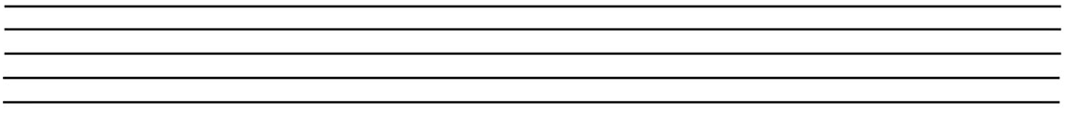
Treble clef 1. B whole 2. G half 3. C quarter 4. F eighth 5. A sixteenth

- Draw a bass clef on the staff. Then draw the note indicated on the pitches indicated. Follow rules given in part I.

Bass clef 1. D eighth 2. B quarter 3. E sixteenth 4. F half 5. G eighth

- Fill in the blank with the correct number.

  - ______ = 
  - ______ =
  - ______ = 
  - ______ =
  - ______ =
  - ______ =
  - ______ =
  - ____ =

