
Tidings of Peace Christian School
Research Paper Class
Ms. Janet
Ms. Janet
9-12th grade
2016-2017

Note to Teacher
This was a two week class I developed for my classroom. Many of the items may not apply to you, but use what is helpful and leave what is not. It was designed to be used with Google Docs and as such it is much easier to navigate if you use with the Document Outline. This can be turned on in the Tools menu or by pressing Ctrl + Alt + A + H.
The Speed writing section can be used as desired. It is simply a place to practice writing quickly without correcting. We spent 5 min per day on a random topic and they were supposed to write non-stop. After they were done they were allowed to make corrections as they wished. This was a way to fight against writer’s block.
Blessings,
Mr. Shenk
Mrshenk@tidingsofpeace.org

Table of Contents
Note to Teacher 3
Table of Contents 4
Introduction 9
Calendars 10
Course Overview 10
Daily Overview 10
Week 1 11
Week 2 12
Paper Evaluation 13
Final Grade 13
English Credit 14
Other Subject Credit 14
Sources 14
Layout 15
Page Numbering 16
Parts 16
Two types of Research Papers 17
Informative 17
Persuasive 17
Identify the type of topic 17
The Steps of a Research Paper 18
Narrowing a Topic 19
Practice Narrowing 19
Select a topic 20
Asking Questions 21
Ask 10 questions about your topic. 21
Navigating the Library 22
Keywords 22
Write key words from your title or synonyms 22
The Dewey Decimal System 23
23
Good Online Sources 24
Libraries 24
Publication Indexes 24
Periodicals 24
Day 1: Conclusion 25
Keep in Mind 27
Day 1 28
Day 2 29
Day 3 30
Day 4 31
Thesis 36
Outline 37
Taking Notes 38
Note Card Examples 39
Hand written 39
Computer 39
Computer Note Cards 41
Checklist 48
Formatting your Works Cited 50

Day 1
Introduction
Included:
- Syllabus
- Two types of Research Papers
- Steps of a Research Paper
- Narrowing a topic
- Asking Questions
- Using the Library
- Online Sources

Course Syllabus

Introduction
Several desired results from taking this course
- The ability to organize thoughts through the discipline of writing
- Improved writing speed
- Understanding how to research using the library
- Greater discernment in note taking
- The ability to give helpful input on other’s writing
- The willingness to receive input in one’s own writing
- Gain expertise in a certain subject
- The satisfaction of working hard to complete a project
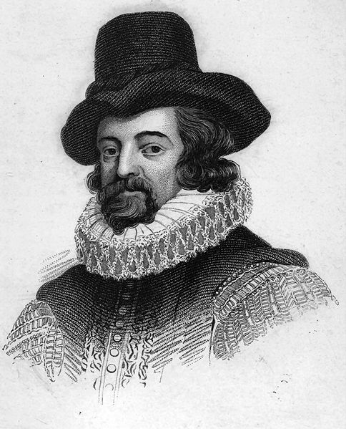
Tip from Sir Francis Bacon: “Reading maketh a full man; conference maketh a ready man; and writing maketh an exact man.”

Calendars

Course Overview
Monday | Tuesday | Wednesday | Thursday | Friday
Star Monday | Narrowing Topic/Library | General Reading |  | Thesis and Outline
Monday | Tuesday | Wednesday | Thursday | Friday
Reading & Note Cards |  | Rough Drafts | Review | Final Copy & Presentations

Daily Overview
- Chapel/Devotions
- Name that Problem
- Class or Work
- Break
- Speedwriting
- Work
- Lunch
- Storytime/Puzzle
- Work

Week 1
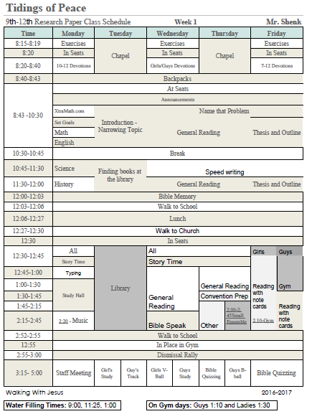

Week 2
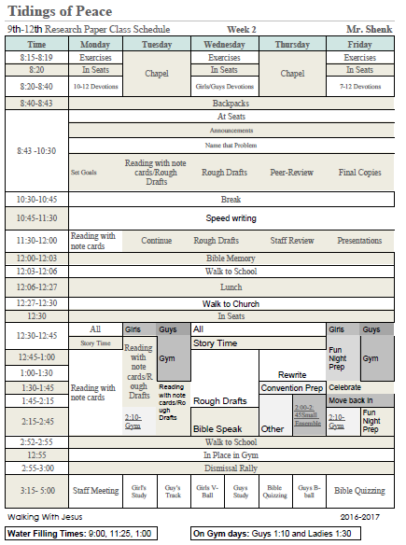

Paper Evaluation

Area | What I’m looking at
Research | Quality and quantity of sources. Awareness of the issues. Notes cards.
Integration | Critical thinking, insight into the subject, and blending of research with own ideas. Good use of evidence. Good statement of thesis.
Organization | Outline and development of the paper. A clear introduction, body, and conclusion. Good support of thesis. Coherence.
Format | Followed the formal requirements for the paper such as title page, length of the paper, margins, citations, and works cited.
Style | Good choice of words and sentences, including precision and variety. Clarity of expression. Good use of transitions. Does the paper read well?
Mechanics | Grammar, punctuation, spelling are correct.

Final Grade

Part | Percent | Grade
Paper | 70
Attendance | 20
Effort | 10

Credit

English Credit
Pages | Sources | Notecards | Stars
3-5 | 3 | 10 | 4
3-5 | 1 B | 1 O | 1 A | 10 | 4
6-7 | 4 | 20 | 5
6-7 | 1 B | 1 O | 2 A | 20 | 5
8-10 | 5 | 30 | 6
8-10 | 2 B | 1 O | 2 A | 30 | 6

Other Subject Credit
Pages | Sources | Notecards | Stars
20 | 10 | 60 | 12
20 | 4 B | 2 O | 4 A | 60 | 12

Sources
Type | Identifier
Book | B
Online | O
Any | A

MLA Format

Layout
- Font: Arial 12-point
- 1 inch margins on all sides
- Single Space in Outline
- Double Space in body
- .5 inch indent at the beginning of all paragraphs
- No headings (ex: Introduction, Body, Conclusion)
- No extra spaces between paragraphs
- Quotes longer than 4 lines must be indented 1 inch from both sides and single spaced as a block, as shown below:
. . . the Palestinians during the British mandate were quite remarkable.
Almost each village had a school, running water, and proper sewage systems for the first time, while the fields were plentiful, and old blood feuds . . . had been settled. In the cities and towns prosperity was also budding. . . . The first graduates of the universities around the Arab world . . . began their professional careers in Palestine. . . . Quite a few chose a public career in the British Mandate government as senior or junior officials. . . . The affluence was visible in the architectural expansion. New neighbourhoods, streets and modern infrastructure were also evident everywhere. (Pappé 16)
Without fear of oppression from the defeated Ottoman Empire, the Palestinians . .

Page Numbering
- All numbering right-aligned and .5 inch from top of page
- Title page no numbering
- Formal outline numbered with name and lowercase Roman numerals
Shenk, Austin i
- Body and Works Cited with name and page # as shown below
Shenk, Austin 5

Parts
- Title page
- Formal outline
- Body
  - Introduction
  - Body
  - Conclusion
- Works Cited

Two types of Research Papers

Informative
Informative papers give information

Persuasive
Persuasive papers argue a specific point

Identify the type of topic
- The Dangers of Drinking
- The Development of a Baby
- Why Obamacare should Stay
- What happened to the Baby Boomers
- The World’s Greatest Musician

The Steps of a Research Paper
Taking it in order
Tip: When you are walking down the steps and you miss one, bad things are sure to happen. Likewise, missing a step in the research process produces frustrating results.
7. Write a final draft
6. Write a rough draft
5. Compile notes to create final outline
4. Take notes while reading
3. Draft a working outline and thesis
2. Create a working bibliography
- Select and Narrow Topic

Narrowing a Topic
The First Step
Tip: A topic such as “World War II” is way too broad. A topic such as “How to Assemble a Sandwich” is too narrow.

Just like a railroad tracks: A properly limited topic will stay focused on the same goal throughout the entirety of the paper.

Practice Narrowing
The Civil War ________________________________________________________________
World Transportation___________________________________________________________
The Turn of the Century________________________________________________________
Solving World Hunger__________________________________________________________

Select a topic
Topic: __________________________________________________
Subject Area:_______________________
Page Goal: 3-5 6-7 8-10 20
Input:

Approved:___________________________


Asking Questions
The direction setting for research

Ask 10 questions about your topic.
You may get help from classmates in this process
- _____________________________________________________________________
- _____________________________________________________________________
- _____________________________________________________________________
- _____________________________________________________________________
- _____________________________________________________________________
- _____________________________________________________________________
- _____________________________________________________________________
- _____________________________________________________________________
- _____________________________________________________________________
- _____________________________________________________________________
Tip: Asking good questions gives positive direction to your project.

Navigating the Library
Finding resources in the powerhouse of the research process

Tip: Although printed books are no longer the fastest method for research they are still very credible.

Keywords
Tip: Searching keywords is a very powerful tool when looking for research resources. Creativity helps in this process.

Write key words from your title or synonyms
- ____________________________
- ____________________________
- ____________________________
- ____________________________
- ____________________________
- ____________________________
- ____________________________

The Dewey Decimal System
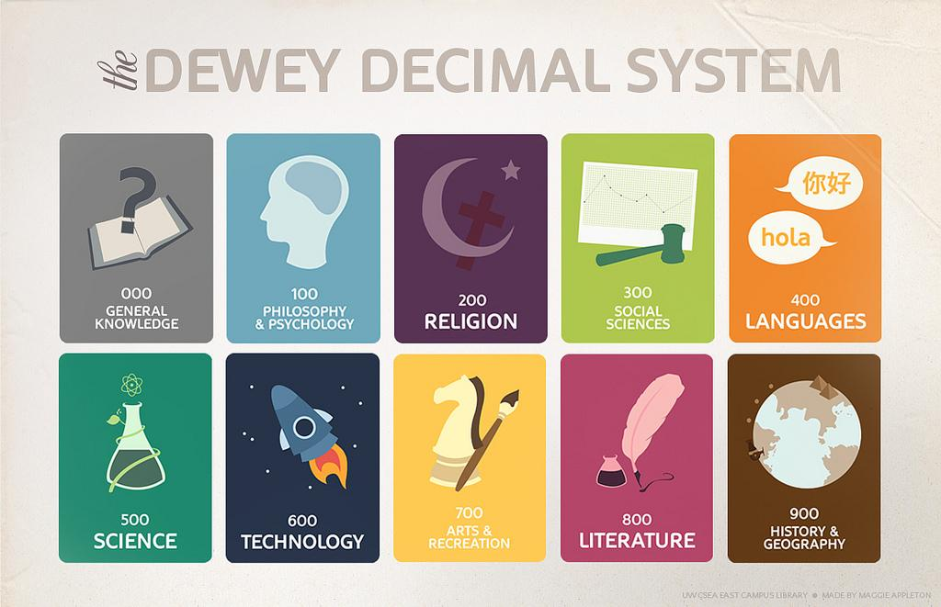
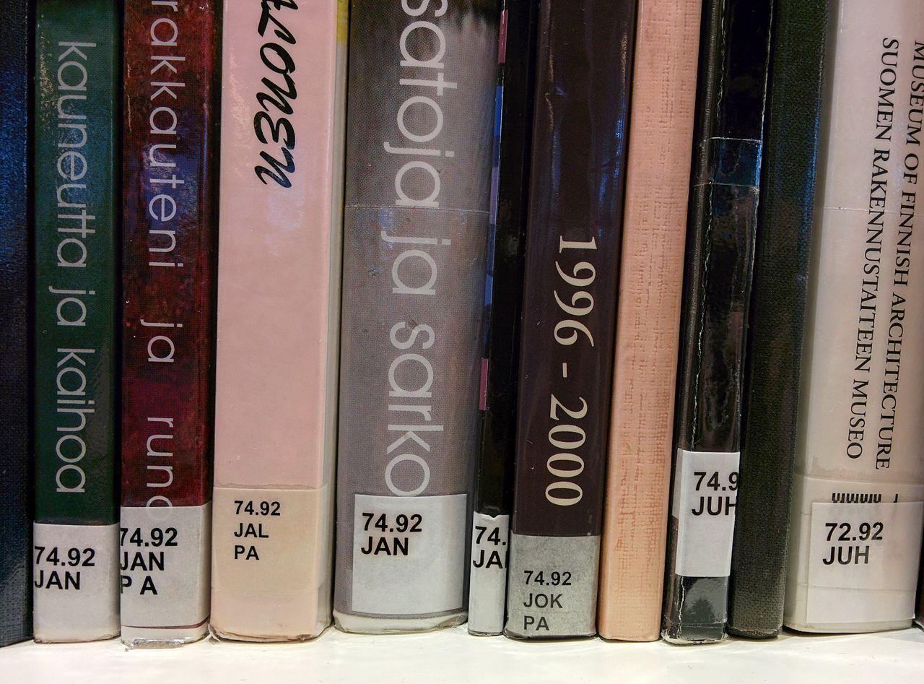
The Dewey Decimal System is a method of organization used internationally “in 200,000 libraries in at least 135 countries.” The genius of the system is displayed by this quote, “Libraries previously had given books permanent shelf locations that were related to the order of acquisition rather than topic. The classification's notation makes use of three-digit Arabic numerals for main classes, with fractional decimals allowing expansion for further detail.”
Identify 5-10 books you plan to find at the library:
- _____________________________________________________________________
- _____________________________________________________________________
- _____________________________________________________________________
- _____________________________________________________________________
- _____________________________________________________________________
- _____________________________________________________________________
- _____________________________________________________________________
- _____________________________________________________________________
- _____________________________________________________________________
- _____________________________________________________________________

Good Online Sources

Libraries
- Martin Memorial Library
- Access PA

Publication Indexes
- Project Gutenberg
- Google Books
- Google Scholar
- WorldCat.org: The World's Largest Library Catalog

Periodicals
- Christianity Today
- World News Group
Tip: In order for your research to be credible you must use reliable, scholarly sources. Although Wikipedia is a great tool for discovering an overview of a topic, it should not be used as a source for your paper.

Day 1: Conclusion
Tip: The process of research may feel intimidating at the moment, but don’t let it get you down. Enjoy the journey!

Writing Improvement
Name that Problem

Keep in Mind
- Avoid
  - Extra words “that” make it seem “that there is” a problem with your exactness.
  - First person (I, we)
  - Passive voice
- Do
  - Shorten Sentences
  - Keep the tense the same (mostly past)
  - Make sure your pronouns agree

Day 1
- Simultaneously, he exemplified judgment and mercy at the same time.
- Often, our consequences of sin lead us to unpleasant circumstances.
- However, obedience is not just obeying a command, but also by repenting from a lifestyle of sin.

Day 2
- Both countries struggled to establish themselves as a nation.
  - Problem: Plural/Singular
  - Solution: Both countries struggled to establish themselves as nations.
- It attracted many Christians from Europe that were facing persecution.
  - Problem: Pronoun
  - Solution: It attracted many Christians from Europe who were facing persecution
- Some would say that they have blessed the nations because they helped to bring a world peace during WWII when Hitler Germany was waging havoc in Europe.
  - Problem: Extra words
  - Solution: Some say they have blessed the nations because they helped to bring world peace during WWII when Hitler’s Germany was waging war in Europe.

Day 3
- She went to the fields to gather food for them; she works hard to support them.
  - Problem: Tense
  - Solution: She went to the fields to gather food for them; she worked hard to support them.
- “This is the way -walk in it.” When we give ourselves to Jesus it shows we believe.
  - Problem: Punctuation
  - Solution: “This is the way -- walk in it.” When we give ourselves to Jesus, it shows we believe.
- God knew this weakness even before they had time to display it and He gave them commandments to help them remember Him.
  - Problem: Extra phrase; punctuation
  - Solution: God knew this weakness, and He gave them commandments to help them remember Him.

Day 4
- They crossed the Jordan to finally enter the Promised Land.
  - Problem: Split infinitive
  - Solution: They crossed the Jordan to enter the Promised Land.
- “Let not the foreigner . . . say, “The LORD will surely separate me.” God’s heart . . .
  - Problem: Quotation marks
  - Solution: “Let not the foreigner . . . say, ‘The LORD will surely separate me.’” God’s heart . . .
- Ruth was a Moabitess yet she was the great-grandmother of David and Jesus.
  - Problem: Extra phrase; punctuation
  - Solution: Ruth, a Moabitess, was the great-grandmother of David and Jesus.

Writing Improvement
Speedwriting

Day 4
Thesis & Outline
Included:
- Thesis
- Outline
- Notecards

Thesis
What question are you answering/position are you taking?

_________________________________________________________________________

What is your BEST answer or strongest position?

_________________________________________________________________________

What is your WEAKEST answer or position?

_________________________________________________________________________

What is your SECOND BEST answer or position?

_________________________________________________________________________

(For persuasive only) What is a concession or opposing view?

_________________________________________________________________________

Enter these items at: https://awc.ashford.edu/writing-tools-thesis-generator.html

Write your the final copy of your WORKING thesis statement here:
_________________________________________________________________________
_________________________________________________________________________
_________________________________________________________________________
_________________________________________________________________________

Outline
Organize your outline in a way that matches your thesis.
- ___________________________________
  - _____________________________
  - _____________________________
    - _______________________
    - _______________________
- ___________________________________
  - _____________________________
  - _____________________________
    - _______________________
    - _______________________
- ___________________________________
  - _____________________________
  - _____________________________
    - _______________________
    - ______________________

Taking Notes
- One note per card
- Quotes must be in quotations
- Write summaries in your own words
- Write why you chose to write this note.

Note Card Examples

Hand written
Outline Item |  | Source #
Page # | Why:

Computer
Outline Item |  | (Author Page #)
Why:

Why

Why

Why

Why

Computer Note Cards
Outline Item |  | (Author Page #)
Why:

Outline Item |  | (Author Page #)
Why:

Format
Examples

Christ’s Kingdom in Palestine

Austin Shenk

ENG 102 English Composition II
Stephen Russell
May 13, 2015

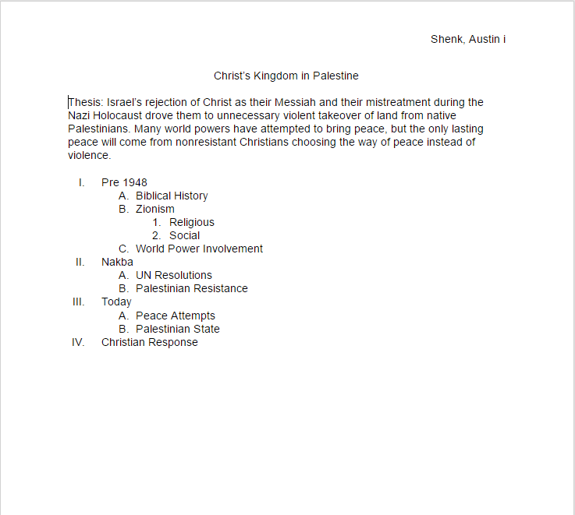

they believed they had full rights to the land. The Palestinian leadership did not mind Jewish settlers, but they hated the idea of giving a part of their land politically to the Jews. "A vital, self-respecting nation does not accept the partition of its homeland" (qtd. in Cohen 231). When the U.N. asked each side for their opinion of the partition plan the Palestinians rejected.
The principled Palestinian and Arab rejection of, and objection to, the partition plan was well known to the Jewish leadership, even before it was asked to respond to the U.N. plan. . . . Nonetheless, Israeli propaganda has ever since quoted Israel's acceptance . . . and the Palestinian rejection as an indication of its peaceful intentions towards the intransigent Palestinians. More importantly, this Palestinian rejection was later used as an explanation by the Israeli government for it decision to occupy parts of the land accorded to the Palestinians in the U.N. partition plan. (Pappé 17)
Palestinians viewed the Zionist establishment as a very temporary invasion, similar to the Crusades and believed they could soon stop them (Kimmerling and Migdal 318-319).
Without an army to defend their land, the Palestinians sought military help from the surrounding Arab countries. Even with their help the Palestinians faced overwhelming odds. Although the British helped Jordan in defense of the Palestinian homeland, their support for the Zionists along with incredible support from the U.S. gave Israel a huge advantage. The general Palestinian public, however, resisted attempts by Arabs to attack the Jews. "Many Palestinian Arabs . . . not only refrained from fighting themselves but also did their best to prevent foreigners and locals from carrying out military actions" (Cohen 233). The Palestinian leadership viewed their opposition as “out and out treason” (233). If the Jews had chosen at this point to live peacefully side by

Works Cited
Bennis, Phyllis. Understanding the Palestinian-Israeli Conflict: A Primer. Northampton: Olive Branch, 2007. Print.
“Balfour Declaration.” History.com. A+E Networks, 2015. Web. 21 Apr. 2015.
Carter, Jimmy. We Can Have Peace in the Holy Land: A Plan That Will Work. New York: Simon & Schuster, 2009. Print.
Chacour, Elias, and David Hazard. Blood Brothers. Grand Rapids: Chosen, 1984. Print.
Cohen, Hillel. Army of Shadows: Palestinian Collaboration with Zionism, 1917-1948. Berkeley: U of California, 2008. Print.
Cohn-Sherbok, Dan, and El Alami Dawoud Sudqi. The Palestine-Israeli Conflict: A Beginner's Guide. Oxford: Oneworld Publications, 2001. Print.
Duiker, William J., and Jackson J. Spielvogel. World History. Belmont, CA: Thomson/Wadsworth, 2007. Print.
Holman Christian Standard Bible. Nashville: Holman Bible Publishers, 2011. Print.
Karesh, Sara E., and Mitchell M. Hurvitz. Encyclopedia of Judaism. New York: Facts on File, 2006. Print.
Kimmerling, Baruch and Joel S. Migdal, The Palestinian People: A History. Cambridge: Harvard UP, 2003. Print.
Olasky, Marvin. “Zion and its enemies.” WORLD 2 May 2015: 30. Print.
Oren, Michael B. Six Days of War: June 1967 and the Making of the Modern Middle East. New York: Ballantine, 2003. Print.
Pappé, Ilan. The Forgotten Palestinians: A History of the Palestinians in Israel. New Haven: Yale UP, 2011. Print.
Ross, Dennis. The Missing Peace: The Inside Story of the Fight for Middle East Peace. New York: Farrar, Straus and Giroux, 2004. Print.
Sizer, Stephen. Christian Zionism: Road Map to Armageddon? Leicester: Inter-Varsity, 2004. Print.

Final
Paper

Checklist
Before handing in your binder make sure you have the following items in this section:
▢ Title page
▢ No page number
▢ Formal outline
▢ Page numbers in Roman numerals
▢ Body
▢ Page numbers in Arabic numerals
▢ Introduction
▢ Conclusion
▢ Works Cited
▢ Only include works you have cited in your paper
▢ Page numbers are the same as the body
Also make sure you have the following:
▢ Note cards (formatted according to example)
▢ Sources (in proper proportion, book and online)
▢ Pages

Works
Cited

Formatting your Works Cited
Working Bibliography
Edman, V. Raymond, Finney Lives On, Minneapolis: Bethany Fellowship, Inc., 1971. Print.

Circle and # the following parts of the the above entry
- Author’s name
- Date of Publication
- Publisher
- Title of the book
- Type of source
- City of Publication
Properly punctuate
Compile your Working Bibliography on the next page . . .

https://www.flickr.com/photos/appletonmaggie/5907672591 Some rights reserved
"Dewey Decimal System - Wikipedia." https://en.wikipedia.org/wiki/Dewey_Decimal_Classification. Accessed 7 Mar. 2017.

