Science Study Sheet
Chapter 7
Air pressure at sea level  Darker areas on the sun’s surface  Field that surrounds the earth to protect it from space particles  Innermost section of the sun  Layer of the atmosphere closest to the earth  Layer of the atmosphere that protects us from meteoroids  Layer in the stratosphere that protects us from the sun’s ultraviolet rays  Light display seen near the poles when solar wind collides with air  Most of the air  Northern lights  Number of miles from the sun to the earth  Strange light that happens in the lower part of the thermosphere  Surface layer of the sun  Term for the scarce amount of air in the top 2 layers of atmosphere  The atmosphere of the sun  The moon blocking out the sun’s light  Top layer of the atmosphere  Vapor blanket surrounding the sun  What the moon looks like when it is gibbous  Where the moon’s light comes from  Closest planet to the sun  Earth’s twin  Largest planet  Only planet suitable for life  Planet discovered by Sir William Herschel  Planet tipped on its side  Planet with 7 bands and 60 rings  Planet with the Great Red Spot  Red planet  Royal blue planet with a moon called Triton | 15 lb. per square inch  Sun spots  Magnetic field  Core  Troposphere  Mesosphere  Ozone layer  Aurora  Nitrogen  Aurora borealis  93,000,000 miles  Airglow  Photosphere  Rarefied  Chromosphere  Solar eclipse  Exosphere  Corona  Bulging  Sun  Mercury  Venus  Jupiter  Earth  Uranus  Uranus  Saturn  Jupiter  Mars  Neptune

Know these constellations.
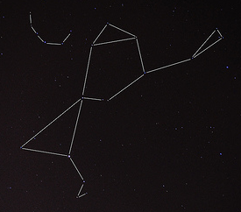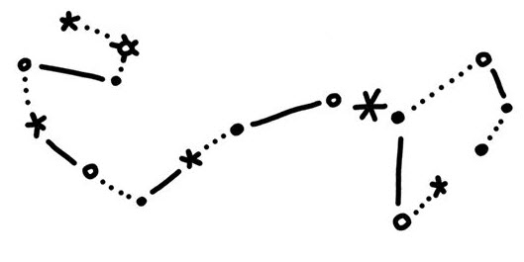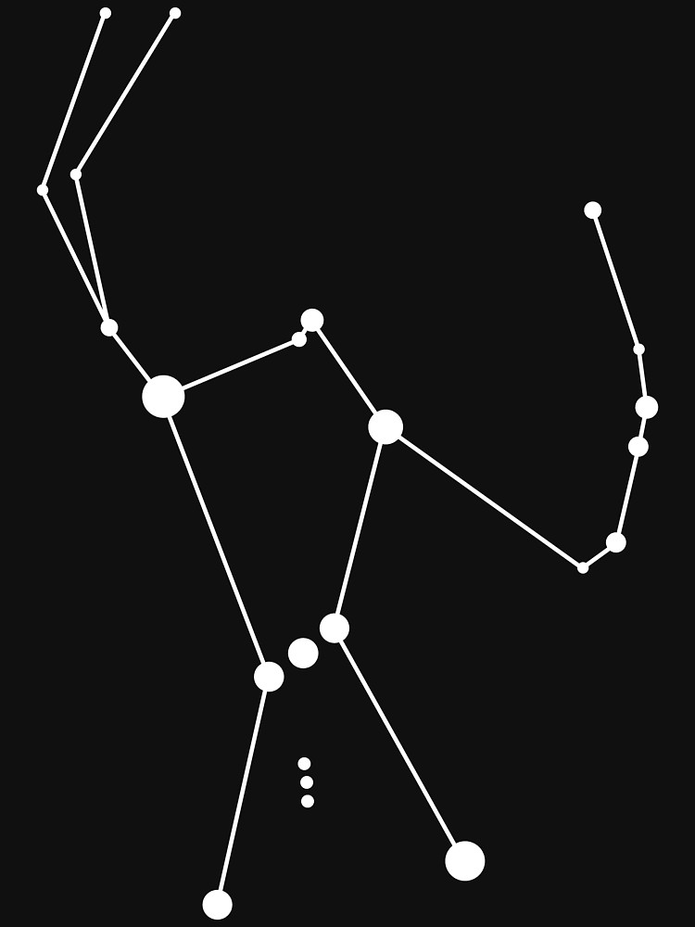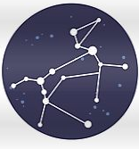

Also know: Great Bear, Southern Cross
Know the phases of the moon.
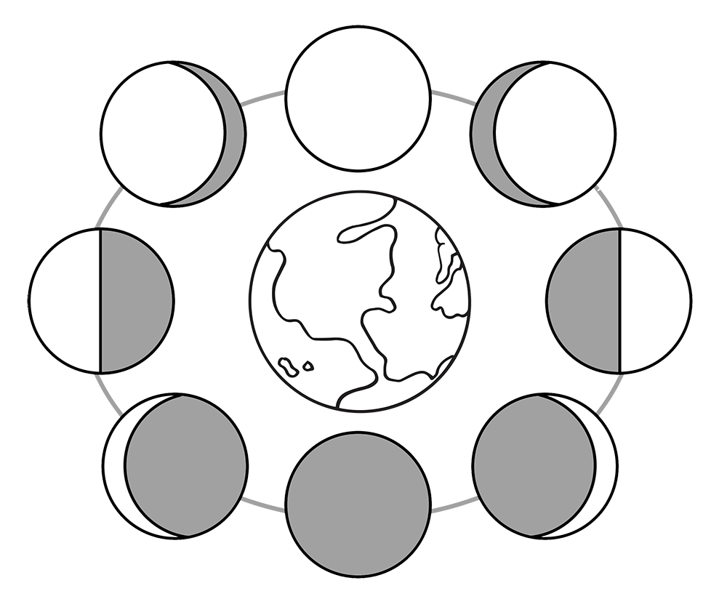
- New moon
- Crescent
- First quarter
- Gibbous
- Full moon
- Gibbous
- Third quarter
- Crescent

5
6 4

7 3

8 2
1

