Algebra I Class Work 7.1
Name ______________________
Directions: You may use your book, notes, calculator, friends, and teacher. However you may not copy someone else work verbatim. Show all your work. If you are not finished at the end of class, write “NEED MORE TIME” at the top and turn your paper in – you may not take it home. You have one week to finish it.
Determine whether the given ordered pair is a solution.
- $3x-4y=2$
$$x+y=7$$
(-2, 9)

Solve each system by graphing.
- $4x+y=9$
$$-x+y=4$$
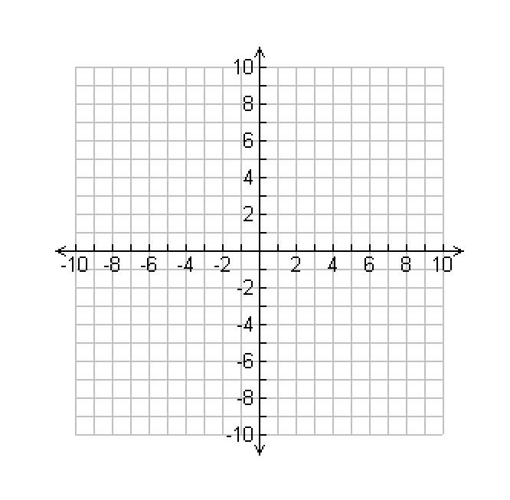

- $5x+y=13$
$$x+2y=-1$$

