Name: _______________ Science Date: _____________
CCU 4

- Fill in the chart.
 | Igneous Rocks | Sedimentary Rocks | Metamorphic Rocks
Formation | Volcanic rocks—  _______ (in the earth)  _______ (above earth) | Formed from ________ of _______________ | Changed by ________ and _____________
Examples | _______________  ________________  ________________  ________________ | _______________  ________________  ________________  ________________ | _______________  _______________

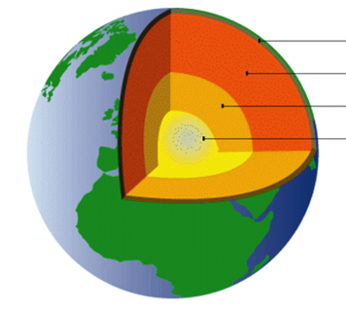
- Label each part of the earth. On the second blank, label them solid, liquid, or both.
1
2
3
4
1. ______________________________
________________________________
2. ______________________________
________________________________
3. ______________________________
________________________________
4. ______________________________
_______________________________
- Fill in the missing words from the definitions.
  - Geologists—a _____________ who studies the ____________ of the ___________
  - Bedrock—a _________, ______________layer of _________ below the ___________
  - Magma—_________, ____________ rock ____________ the earth
  - Lava—__________ that has ____________ through the earth’s ___________
  - Weathering—the forming of ___________ from _____________
  - Natural resource—any __________ found in God’s _________ which is __________ to man
  - Humus—_____________ plant and animal ______________
  - Mineral—a ____________ that forms a special kind of ____________ called a ___________
  - Crystal—a ___________form of a ___________ having a definite _________, flat ___________, sharp ____________
  - Geode—a ____________ object that was formed in a ___________ deposit; it looks like a ____________ and has _____________ inside
  - Gemstone—a ____________, ______________ mineral which is very __________
  - Mineralogist—a _____________ who studies _____________
  - Stalactite—a ___________ formation _____________ from the _________ of a _________; formed by the _______________ of dripping water filled with ____________
  - Stalagmite—a __________ formation ___________ up from the _________ of a _________
  - Petroleum—an ____________ or _______________ ________ (in its __________ state)
  - Coal—a _________ or _________ rocklike substance found in _________ of _________
  - Fossil—the ______________ remains of a ___________ or ______________
  - Paleontologist—a ______________ who studies _____________

- Answer the questions in part D.
  - _________________________________________________________________________
  - __________________________________________________________________________________________________________________________________________________
  - ____________________
  - _______________________________
  - _______________________________
  - _________________________________________________________________________
  - __________________________________________________________________________________________________________________________________________________
  - ___________________________________________________________________________________________________________________________________________________________________________________________________________________________

- Answer the questions in part C.
- _________________________  - _________________________  - _________________________  - _________________________  - _________________________  - _________________________  - _________________________  - _________________________  - _________________________  - _________________________ | - _________________________  - _________________________  - _________________________  - _________________________  - _________________________  - _________________________  - _________________________  - _________________________  - _________________________

- Answer each question in part D.
- _______________________ and __________________________
- _________________________________________________________________________
- __________________________________________________________________________________________________________________________________________________

