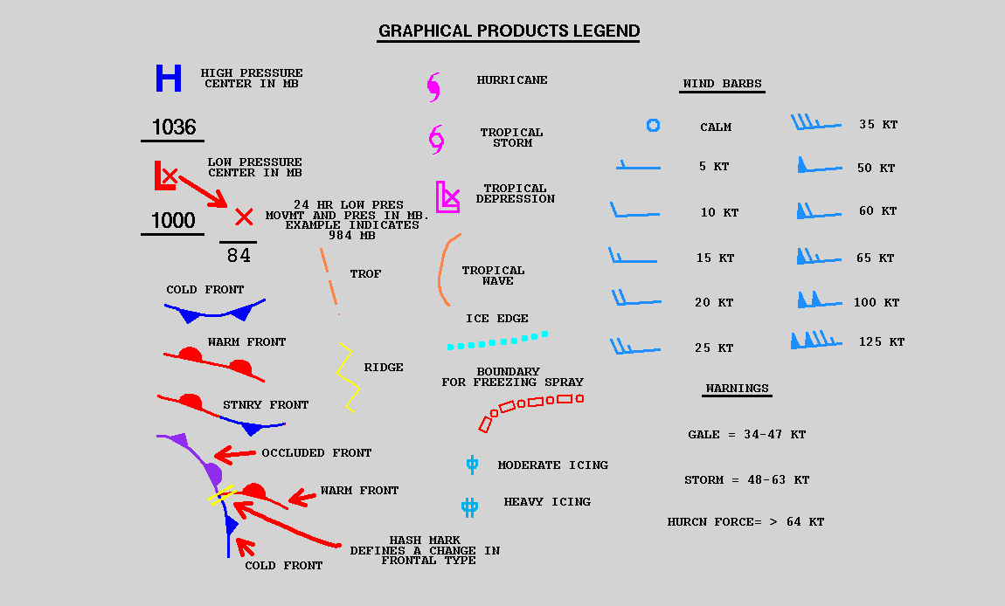
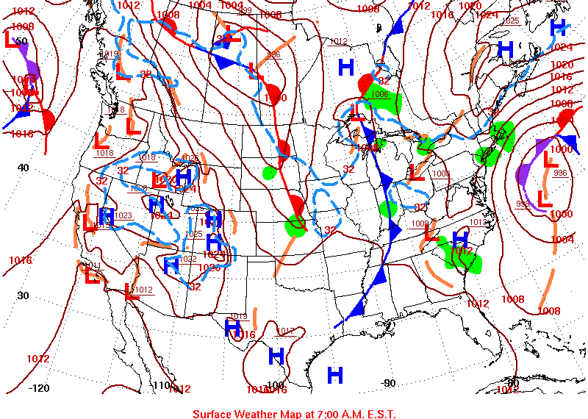
- What was the pressure in northern Oklahoma? ______________
- Label a warm front.
- What is happening in a warm front? __________________________________________
- Label a cold front.
- What is happening in a cold front? ___________________________________________
- Label an occluded front.
- What is happening in an occluded front? ______________________________________
- Label a trough.
- What direction do you predict the wind was blowing in Pennsylvania? ______________

