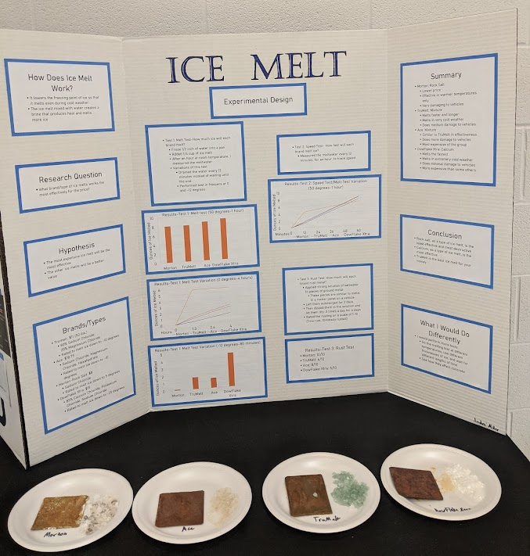
Design elements to consider:
- Font size should be at least 14-point. It should be readable from several feet away, so 16-point fonts are probably better.
- Try not to make your poster too “busy.” Attendees should be able to get the main point of your experiment in two minutes or less.
- Adding decorations to your design should come at the end. Don’t spend three days creating a beautiful title and then need to rush the other parts of your design. Remember: the poster is supposed to communicate your message. If it looks beautiful but doesn’t say anything, it will be a waste of time for both you and your audience.
- Charts and pictures can make a huge difference in both the interest and the value of your poster.
Optional parts of the display:
- Background information
- Charts and graphs
- Design changes
- Sample of materials
Necessary parts of the poster:
- Title: Top center
- Research Question
- Hypothesis
- Experimental Design
- Results
- Conclusion

