Multiple Choice
_____ |  | Which of the following is true of neurons?  - Neurons use very little energy. C. Neurons have an all-or-nothing response cycle.  - Neurons get replaced regularly. D. Neurons can communicate in two directions.
_____ |  | Which of the following is true of the motor division of the peripheral nervous system?  - It sends signals to the CNS. C. It receives signals from the CNS.  - It moves nerves around. D. It is responsible for reflex loops.
_____ |  | What kind of cells support neurons?  - Neurotransmitters C. Langerhans cells  - Glial cells D. Dendrite cells
_____ |  | About what percent of your calories are consumed by your brain?  - 10% C. 40%  - 25% D. 55%
_____ |  | What is the general purpose of sensory organs?  - Filter sensory information. C. Convert analog signals to electrical signals.  - Integrate sensory information. D. Use myelin to detect surroundings.
_____ |  | The pituitary gland is part of the _____________ system.  - nervous C. reproductive  - endocrine D. digestive
_____ |  | Glands in the __________ system release hormones to regulate body responses.  - respiratory C. lymphatic  - endocrine D. urinary
_____ |  | Puberty, long-term stress response, blood sugar levels, and metabolism are all controlled by the __________ system.  - endocrine C. reproductive  - urinary D. digestive
_____ |  | Which gland(s) is/are responsible for the facial hair, deepened voice, and aggressive behavior found in adult males?  - pituitary gland C. testes  - pineal gland D. thymus
_____ |  | Which gland produces growth hormones?  - pituitary gland C. pineal body  - adrenal gland D. thymus
_____ |  | Which structure produces large amounts of estrogen and progesterone?  - ovary C. testis  - uterus D. pituitary gland
_____ |  | Which of the following is an example of a positive feedback system?  - An increase in sugar level in the blood triggering the release of a hormone that causes the liver and muscles to pull sugar out of the blood.  - A decrease in sugar level in the blood triggering the release of a hormone that causes the liver and muscles to release sugar into the blood.  - An inflamed tendon swelling and rubbing against a bone, further inflaming the tendon.
_____ |  | The brain is part of the  - peripheral nervous system. C. sympathetic nervous system.  - central nervous system. D. parasympathetic nervous system.
_____ |  | You wake up to find your house is on fire. What do you hope gets activated quickly?  - autonomic nervous system C. sympathetic nervous system  - somatic nervous system D. parasympathetic nervous system
_____ |  | Which gland is the “master gland” that controls many other glands?  - pineal body C. pituitary gland  - adrenal gland D. pancreas
_____ |  | What are the male reproductive organs that produce sperm?  - ovaries C. seminal vesicles  - testes D. uteruses
_____ |  | If an ovum reaches the ________ without being fertilized, it triggers the relining of the ___________. (The same word fits in each blank.)  - ovaries C. uterus  - fallopian tubes D. cervix
_____ |  | Which of the following is a sexually transmitted infection?  - Shigella C. Chlamydia  - Mononucleosis D. Rubella
_____ |  | Which category of birth control methods may include options that could cause abortions?  - Barriers C. Natural methods  - Hormonal methods D. Surgical methods
_____ |  | Which of the following is not involved in reproduction?  - Intercourse C. Fertilization  - Pollination D. Implantation
Short answer:
- Tell three functions of the nervous system.
  - ___________________________________ c. ___________________________________
  - ___________________________________
- Fill in the concept map with the words autonomic nervous system, central nervous system, nervous system, parasympathetic nervous system, peripheral nervous system, somatic nervous system, and sympathetic nervous system.

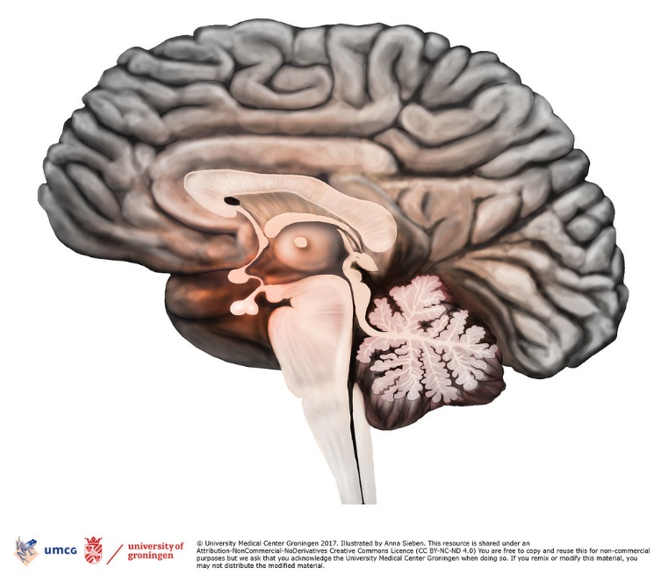
- In the drawing below, label the following structures: brain stem, cerebellum, cerebrum. For extra credit, you may label the lobes of the brain.
- Does practice make perfect? Explain.

- Consider the analogy of “feeding” your brain with different types of materials. Give some examples of materials (books, videos, music) that would be analogous to each type of food:

  - Steak and potatoes (good, but takes a lot of work)

  - Cereal (easy, but of limited benefit)
  - Oreos (easy, and enjoyable, but damaging as a regular part of the diet)

  - Alcohol (enjoyable in the moment, but very damaging)
- Draw a typical neuron and label the axon, dendrites, and soma (cell body). Also tell the functions of the axon and the dendrites.
- Tell three functions of the endocrine system.
  - ___________________________________ c. ___________________________________
  - ___________________________________
- Which glands produce epinephrine (also called adrenaline)?
- Give an example of a negative feedback loop.
- Fill in the chart below comparing the nervous system and the endocrine system.
 | Nervous System | Endocrine System
Mode of control
(direct or indirect)
Speed of response
(fast or slow)
Duration of influence
(short or long)
Effectors they control
Strength of signal
(all-or-nothing or variable)
Repair
(possible or not possible)

- Name an organ where meiosis occurs.
- Describe what each of the following scripture passages tells us about the moral aspect of the reproductive system?
  - 1 Cor. 3:16:
  - 1 Cor. 6:12-17:

  - Romans 12:1-2:
Extra credit:
- How are steroids different from non-steroid hormones?
- What is HPV?

- What kind of cells are reproducing uncontrollably when someone has brain cancer?
- What is meant by the statement, “You see with your mind, not with your eyes”?

