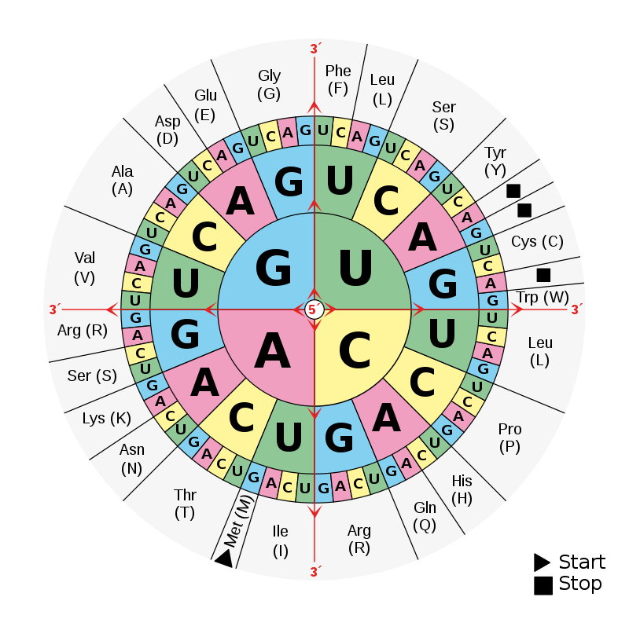
AMINO ACID | THREE-LETTER | ONE-LETTER | AMINO ACID | THREE-LETTER | ONE-LETTER
Alanine | Ala | A | Leucine | Leu | L
Arginine | Arg | R | Lysine | Lys | K
Asparagine | Asn | N | Methionine | Met | M
Aspartic Acid | Asp | D | Phenylalanine | Phe | F
Cysteine | Cys | C | Proline | Pro | P
Glutamic Acid | Glu | E | Serine | Ser | S
Glutamine | Gln | Q | Threonine | Thr | T
Glycine | Gly | G | Tryptophan | Trp | W
Histidine | His | H | Tyrosine | Tyr | Y
Isoleucine | Ile | I | Valine | Val | V

