Church History

Migration to the Deep South
- Background
  - Vision in Virginia for outreach and expansion (still Virginia Conf.)
  - Lots of open land (in terms of Anabaptist influence) and opportunity in the South

- The beginning
  - First settlers
    - James Eshleman—June, 1957
    - John Barnhart—Beginning of 1958
    - Jerry Yoders—1961
    - Earl Hartzlers—1964
    - Edgar Strites—1965
  - Establishment of churches
    - Hephzibah Mennonite Church
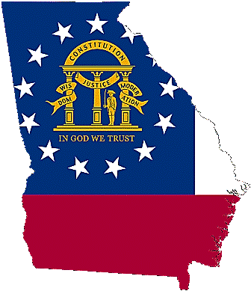
      - Families met in homes for first number of years
      - Church house was built around 1964
      - New auditorium built in 1990
    - Burkeland Mennonite Church
      - First families included Byard Heatwole and James Landis
      - Families began meeting for worship in 1970 and the church was built in 1974

    - Barnwell Mennonite Church—established in 1973
    - South Atlantic Mennonite Conference was formed in 1995
    - Lighthouse Mennonite Church in Monticello, GA
      - Started meeting in home of Ricky Wright in 1993
      - Church house built in Monticello in 1997
    - Edisto Mennonite Church—established in 2012 in response to overcrowding at Barnwell
    - Bethel Mennonite Church—established in 2015 after the Presbyterian church offered to give the their church building in Vidette to Burkeland Mennonite. Having become rather full at Burkeland, the membership there took this opportunity as a sign to spread out a little.
  - Waynesboro Mennonite School
    - School was first held in the basement of HMC, beginning in 1971 (First school board consisted of Elmer Bontrager, James Eshleman, and Jerry Yoder; first teachers: Martha Wenger and Daniel Hartzler)
    - WMS was built around 1981 and had its first school year in 1982-1983
    - Addition of high school room c. 1990

