Church History

Mennonites in the World Wars
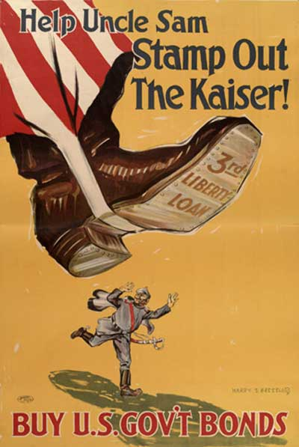
- World War I
  - Background to the challenge for Conscientious Objectors
    - US remained neutral during the first several years of the war
    - Once the US entered the war, a massive propaganda machine was created to convince the American people that the cause was just and right and to ensure their active support (75,000 speakers were organized to give speeches across the country, promoting the war effort)—this was successful
    - The groundswell of public support for the war effort raised the stakes for anyone who did not join the bandwagon of participating in or at least cheering on the war effort
    - The draft was enacted in 1917, conscripting all men 21-30
  - Official response to the involvement in war
    - General Conference—many leaders expressed reservations about participation but they left the decision about participation up to the individual person
    - “Old” Mennonite conferences—leaders passed a resolution in 1917 making it clear the they opposed participating in the war and that such participation would be a test of membership
  - Options for COs
    - For most of the war, the government’s position on conscientious objection to war was fuzzy and unclear; in reality, they had no clear position for some time
    - No provisions were made for an alternative to the draft; everybody had to comply with the military or be court-martialed; the military did normally allow for some type of noncombatant role for COs
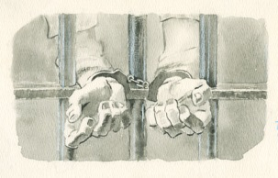
    - Non-cooperation—some Mennonites refused to even wear the uniform or comply with any kind of military orders—browbeating, manhandling, and imprisonment
      - George S. Miller—harsh treatment (Juhnke 208-209)
      - Hofer brothers—death (239-240)
    - Partial cooperation
    - Toward the end of the war, the War Department softened its policy on COs and allowed some to be sent to work on farms
  - Public response to Mennonites—because the spirit of patriotism and warmongering had grown very strong, there was a lot of public opposition to the Mennonite position
    - Editorials against them
    - Houses and churches painted with yellow paint
    - Two church houses burnt down—Michigan and Oklahoma
    - Mob violence—in a number of instances, Mennonites were nearly hanged by angry mobs but were rescued in time
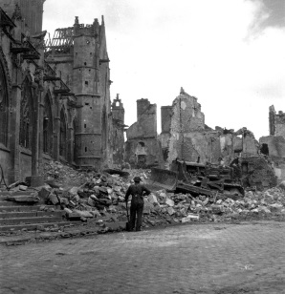
- World War II
  - Background—both sides were better prepared for the conflict
    - Mennonites maintained a solid opposition to participating in the war; a statement from the Eastern district said, “War is sin; we can have no part in it personally or by aiding those who fight. We cannot serve in any branch of military, combative or non-combative. War bonds should not be purchased.”
    - Even so, a significant number of young men joined the war—in Franconia conference, half of the draftees joined the military
    - In 1937, representatives of the historic peace churches presented a position letter to Pres. Roosevelt in preparation for a potential draft
    - Mennonite Central Peace Committee was formed to coordinated efforts
    - In 1940, a second meeting with the President was held and more concrete proposals were offered for an alternative service
    - When the draft was enacted later in 1940, the government allowed for an alternative to the draft—civilian public service
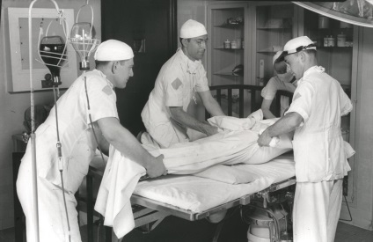
  - Civilian Public Service (CPS)
    - CPS was operated and funded by the MCC and some other Brethren and Quaker organizations in cooperation with the Selective Service
    - COs were not necessarily given a free pass to CPS, but if their lives substantiated their conscientious opposition to taking human life, they were granted this opportunity
    - Fields of activity
      - Forestry, soil conservation, dam-building, firefighting
      - Mental health hospitals, public health
      - Agricultural research and farming
  - Relief work—After the war, many Mennonites contributed to and participated in relief work for those affected by the war

Homework Assignment:
April 2020
The United States has gotten into a war with North Korea and China. Since volunteers has not kept pace with the need for soldiers, the US has enacted another draft, this time calling women as well as men between the ages of 18 and 42. Your number has been picked and you appear before a draft board. How would you respond to the question: “Why do you conscientiously object to participating in war?”
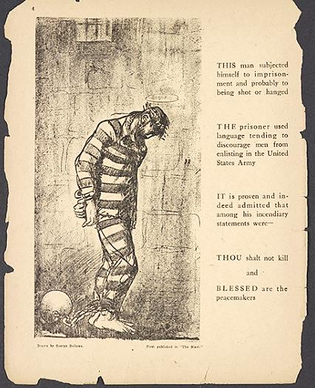
Blessed are the Peacemakers by George Bellows

