Church History

Encounter with New Ideas
- Encounter with new Christian emphases
  - ________________—Mennonites were exposed to pietistic ideas through contact with other German-speaking religious groups
    - Emphasis on emotion and experience over reason and doctrine
    - Is your heart right? Not as much, “Do you believe right?”
    - More emphasis on the individual and not as much on the church
  - _____________________
    - Focus on dramatic conversion; less on discipleship
    - Fiery, emotional preaching
    - Charismatic singing and worship
    - Centered in non-church and para-church settings, not in the local church
    - Sunday schools often came along with this movement
  - _________________________
    - Optimistic belief in man’s ability to improve society
    - Emphasis on education and science
    - Openness to general society’s values—individualism, patriotism, prosperity/ consumerism
    - Systems and institutions
  - Threatened values
    - Humility and meekness
    - Accountability, openness, and deference to the brotherhood of believers
    - Cross-bearing discipleship
    - Active role of the local body in decision-making
- Responses to the new emphases- Hesitation, embracing, and a certain amount of tension
  - John Holdeman—Church of God in Christ, Mennonite—1859
  - Church of the Brethren
  - Old Order groups—see note on p. 186-187 of Through Fire and Water
  - General Conference Mennonites

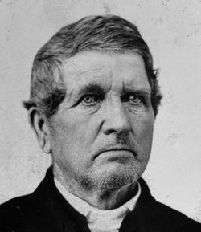
    - In the mid-1800s, John Oberholtzer, one of the most “progressive” in the Mennonite camp, wrote up a new constitution proposing many of the changes he desired and tried to get the rest of the churches to accept it
    - Some of the changes he proposed:
      - Less restriction on participating in government
      - Less restriction on going “to the law”
      - No separation and nonconformity
      - Outside marriages permitted
      - Those baptized as infants need not be re-baptized
    - This document and its proponents were seeking to pattern church life after the surrounding culture and society
    - In 1847, the “progressive” group parted ways with the rest of the Mennonites
      - Oberholtzer wanted his constitution read at conference in 1847
      - Because of its position, it was neither read or accepted
      - Oberholtzer’s group literally walked out of the meeting
      - This group became known as the General Conference (GC)—liberal legacy, e.g. Oberholtzer’s son fought in the Civil War

