Church History

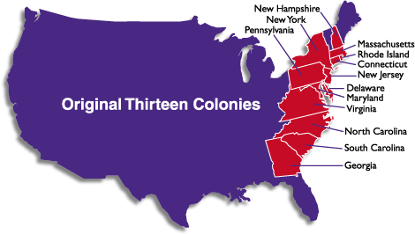
Mennonites and the American Revolution
- Background
  - Between 1600 and 1750, England claimed ownership and governing rights to thirteen colonies on the eastern seaboard of this new land called America
  - A steady stream of immigrants from many parts of Europe had settled in these regions, and while they were technically under British rule, they exercised a lot of self-government. The British were too busy and too distracted to pay really close attention to what was happening in the colonies.
  - So when, after the French and Indian War, King George III decided to have the colonists helped cover the cost of this conflict by enacting some taxes and made some changes to the structure of government that gave the British more control in colonial affairs, many colonists reacted in anger and distrust
  - Provocations on both sides led to heightened tensions and eventually war. From the British perspective, the colonists were outright rebels who flouting the rule of law. From the rebels’ perspective, they were standing up for their rights against the demands of a tyrant.
  - Though there were many colonists who did not support or join the rebellion against the English crown, those who did (the Whigs), were extremely vocal, putting a lot of pressure on everyone to support and join their cause; they soon defamed everyone else as traitors and “Tories.” Quote from Thomas Paine: “Every tory is a coward; for servile, slavish, self-interested fear is the foundation of toryism..”
- The Mennonites’ dilemma
  - When the Mennonites had moved into Pennsylvania from western Europe, they had needed to accept the English government in the colonies and in some cases promised to be subject to the King of England—now their neighbors were pressuring them to turn against this king
  - The Mennonites believed that the Scripture taught obedience and respect for one’s government even if it did step on its citizen’s toes (Romans 13)
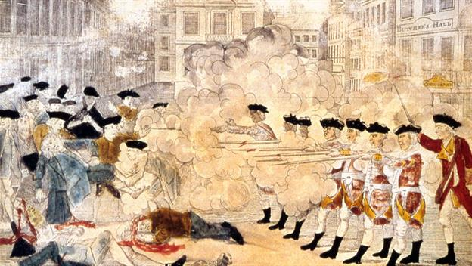
  - The Mennonites had always taught nonresistance: that violence and killing were wrong and that Christians should love their enemies and do good to them like Christ taught
- Crossfire: From freedom to harassment
  - Social harassment:
    - Mennonites were called tories and cowards
    - They faced the threat of being tarred and feathered
  - Economic harassment:
    - Colonial militias confiscated guns, crops, and livestock from the Mennonites to use in their cause. The British armies also helped themselves to some of the Mennonites’ provisions.
    - Draft laws were passed in PA and those who refused to serve in the army were fined five shillings a day.
  - Political harassment:
    - Those who refused to swear an oath of allegiance to the new Whig government lost many rights of citizenship—the right to buy or sell property, to travel outside of their home vicinity, and to adopt children.
    - The property of some Mennonites was seized in response an unwillingness to change allegiances.

