Church History

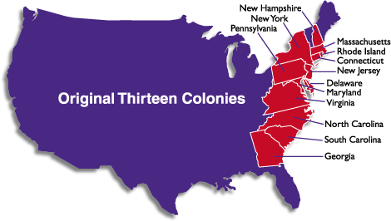
Mennonites and the American Revolution
- Background
  - Between ______ and ______, England claimed ownership and governing rights to thirteen colonies on the eastern seaboard of this new land called America
  - A steady stream of immigrants from many parts of Europe had settled in these regions, and while they were technically under British rule, they exercised a lot of ________-government. The British were too busy and too distracted to pay really close attention to what was happening in the colonies.
  - So when, after the French and Indian War, King George III decided to have the colonists helped cover the cost of this conflict by enacting some ___________ and made some changes to the structure of government that gave the British more control in colonial affairs, many colonists reacted in ______________ and distrust
  - Provocations on both sides led to heightened tensions and eventually _______. From the British perspective, the colonists were outright _____________ who were flouting the rule of law. From the rebels’ perspective, they were standing up for their ________ against the demands of a tyrant.
  - Though there were many colonists who did not support or join the rebellion against the English crown, those who did (the __________), were extremely vocal, putting a lot of pressure on everyone to support and join their cause; they soon defamed everyone else as _____________ and “Tories.” Quote from Thomas Paine: “Every tory is a coward; for servile, slavish, self-interested fear is the foundation of toryism..”
- The Mennonites’ dilemma
  - When the Mennonites had moved into Pennsylvania from western Europe, they had needed to accept the English government in the colonies and in some cases promised to be ______________ to the King of England—now their neighbors were pressuring them to turn against this king
  - The Mennonites believed that the Scripture taught _____________ and _____________ for one’s government even if it did step on its citizen’s toes (Romans 13)
  - The Mennonites had always taught nonresistance: that violence and _____ were wrong and that Christians should love their enemies and do good to them like Christ taught
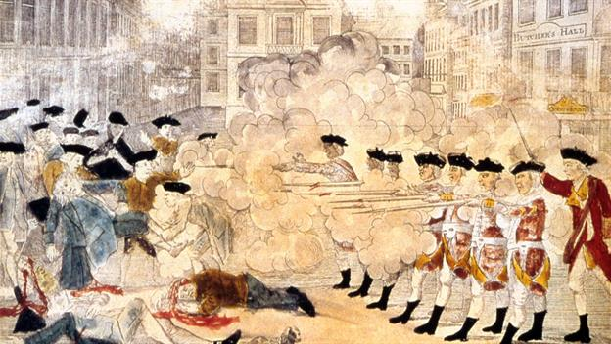
- Crossfire: From freedom to harassment
  - _____________ harassment:
    - Mennonites were called ___________ and cowards
    - They faced the threat of being tarred and _____________________
  - ____________________ harassment:
    - Colonial militias confiscated guns, crops, and livestock from the Mennonites to use in their cause. The British armies also helped themselves to some of the Mennonites’ provisions.
    - Draft laws were passed in PA and those who refused to serve in the army were fined _______________________ a day.
  - ________________________ harassment:
    - Those who refused to swear an oath of allegiance to the new Whig government lost many rights of _____________________—the right to buy or sell property, to travel outside of their home vicinity, and to adopt children.
    - The ___________________ of some Mennonites was seized in response an unwillingness to change allegiances.

