Church History

Mennonite Experiences in Pre-Revolution American: Two Stories
- Jacob Hochstetler family massacre (Gathering at the Hearth 15-18)
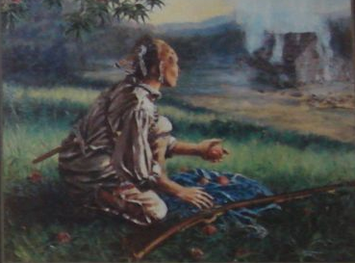

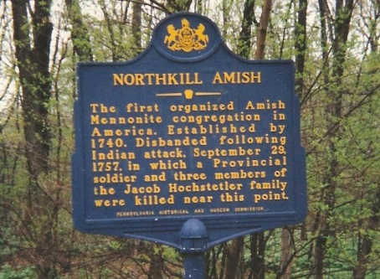

- Mennonites, Indians, and the Paxton Boys (‘Twas Seeding Time 26-28)

