Church History

Mennonite Emigration to North America and Early Settlements
- Background
  - From capital punishment to discrimination
    - Hans Landis was the last Mennonite to be executed for being an Anabaptist—1614
    - However, the Mennonites still faced much opposition and persecution
      - Galley slaves
      - Extra taxes—i.e. tax for not being a part of the state church
      - Inheritance limitations
      - Mennonites’ land could be sold for the same price for which it was bought regardless of the amount of development
      - Fines for various offenses
      - Social rejection
  - Around 1650, many Swiss Mennonites moved down the Rhine River valley to a region called the Palatinate. This area had been badly destroyed during the Thirty Years War, and some of its rulers wanted Mennonite farmers to help restore the land. Here the Mennonites mingled with Quaker groups to a certain extent.
- William Penn’s invitation
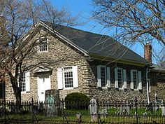
  - After receiving a large tract of land in America from the King of England, Penn invited Quakers and Mennonites to move to “Penn’s Woods” in the late 1600s.
  - First permanent Mennonite settlement in America—Germantown—1683
  - More Mennonite emigration from Europe to North America soon followed (read first-hand account of Christian Ropp in Glimpses of Mennonite History and Doctrine, p. 102-104)
    - Confession of Faith was translated into English in the early 1700s
    - First baptismal service and communion in 1708
  - People of note among early Mennonites
    - William Rittenhouse—first Mennonite minister in America
    - Christopher Dock—schoolteacher
  - Places of early settlement
    - Franconia
    - Lancaster
    - Ohio
    - Indiana
    - Illinois
    - Waterloo, Ontario
    - Virginia

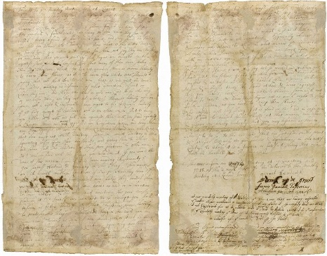
The Germantown Protest (1688)
On February 18, 1688, in response to fellow Quaker families in Germantown, Pennsylvania, who had decided to practice slavery, members of the Society drafted this first protest against slavery in the new world.
This is to ye monthly meeting held at Richard Worrell's.
These are the reasons why we are against the traffik of men-body, as followeth. Is there any that would be done or handled at this manner? viz., to be sold or made a slave for all the time of his life? How fearful and faint-hearted are many on sea when they see a strange vessel — being afraid it should be a Turk, and they should be taken, and sold for slaves into Turkey. Now what is this better done, as Turks doe? Yea, rather is it worse for them which say they are Christians, for we hear that ye most part of such negers are brought hitherto against their will and consent and that many of them are stolen. Now tho they are black we cannot conceive there is more liberty to have them slaves, as it is to have other white ones. There is a saying that we shall doe to all men like as we will be done ourselves; making no difference of what generation, descent or colour they are. And those who steal or rob men, and those who buy or purchase them, are they not alike? Here is liberty of conscience wch is right and reasonable; here ought to be likewise liberty of ye body, except of evil-doers, wch is an other case. But to bring men hither, or to rob and sell them against their will, we stand against. In Europe there are many oppressed for conscience sake; and here there are those oppossd who are of a black colour. And we who know that men must not commit adultery — some do commit adultery, in others, separating wives from their husbands and giving them to others; and some sell the children of these poor creatures to other men. Ah! doe consider well this thing, you who doe it, if you would be done at this manner? and if it is done according to Christianity? You surpass Holland and Germany in this thing. This makes an ill report in all those countries of Europe, where they hear off, that ye Quakers doe here handel men as they handle there ye cattle. And for that reason some have no mind or inclination to come hither. And who shall maintain this your cause, or pleid for it? Truly we can not do so, except you shall inform us better hereof, viz., that Christians have liberty to practise these things. Pray, what thing in the world can be done worse towards us, than if men should rob or steal us away, and sell us for slaves to strange countries; separating housbands from their wives and children. Being now this is not done in the manner we would be done at therefore we contradict and are against this traffic of men-body. And we who profess that it is not lawful to steal, must, likewise, avoid to purchase such things as are stolen, but rather help to stop this robbing and stealing if possible. And such men ought to be delivered out of ye hands of ye robbers, and set free as well as in Europe. Then is Pennsylvania to have a good report, instead it hath now a bad one for this sake in other countries. Especially whereas ye Europeans are desirous to know in what manner ye Quakers doe rule in their province — and most of them doe look upon us with an envious eye. But if this is done well, what shall we say is done evil?
If once these slaves (wch they say are so wicked and stubborn men) should joint themselves — fight for their freedom, — and handel their masters and mastrisses as they did handel them before; will these masters and mastrisses take the sword at hand and warr against these poor slaves, licke, we are able to believe, some will not refuse to doe; or have these negers not as much right to fight for their freedom, as you have to keep them slaves?
Now consider well this thing, if it is good or bad? And in case you find it to be good to handel these blacks at that manner, we desire and require you hereby lovingly that you may inform us herein, which at this time never was done, viz., that Christians have such a liberty to do so. To the end we shall be satisfied in this point, and satisfie likewise our good friends and acquaintances in our natif country, to whose it is a terror, or fairful thing that men should be handeld so in Pennsylvania.
This is from our meeting at Germantown, held ye 18 of the 2 month, 1688, to be delivered to the Monthly Meeting at Richard Worrell's.
Garret hendericks. derick up de graeff, Francis daniell Pastorius, Abraham up Den graef

