Church History

Amish Roots
- Disagreement among the Swiss Mennonites
  - Era of time - late 17th century
  - Background: The Swiss Mennonites began to experience a certain amount of acceptance from their communities, which led to led to friendlier relationships with those outside the church and a more relaxed attitude about their lifestyle. Tension developed as a result of different responses to this shift.
  - Issues
    - Use of the ban
    - Relationship with the “Half-Anabaptists”
    - Frequency of Lord’s Supper and the practice of foot-washing
    - Simple clothing and lifestyle, including beards for men
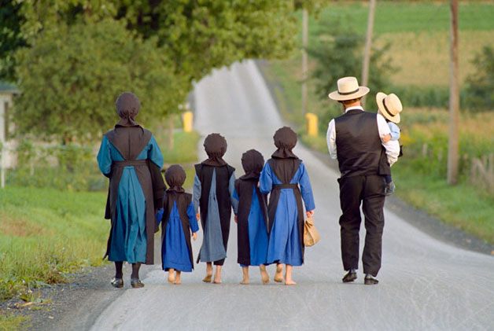
  - Leaders of the two sides
    - Hans Reist—Mennonite
    - Jacob Amman—Amish
- The Split
  - Meetings were held to discuss issues
  - Neither side was willing to yield

  - Insensitivity and lack of love was shown on both sides
  - Amman excommunicated those who disagreed with him
  - People and congregations chose sides
  - Amman’s attempts at reconciliation were rebuffed
  - Various more attempts at reconciliation were unsuccessful

How Should Christians Handle Disagreements?
- Seek first to understand and then to be understood. Take into account differences in background and experience.
- Discuss the ideas, never attack people; don’t allow personality issues to cause permanent divisions.
- Do all in love and humility (Anger makes real communication impossible).
- Stand for what is true, but always seek for reconciliation.

