Two Important Anabaptist Books
- Ausbund: Collection of hymns by the early Anabaptists
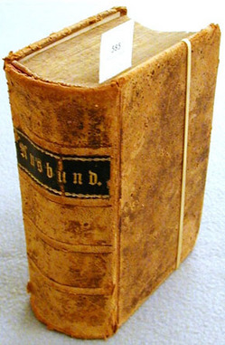

- The Martyrs’ Mirror: Collection of martyr stories by early Anabaptists
