Church History

Mennonites in Russia
- The open door to Russia
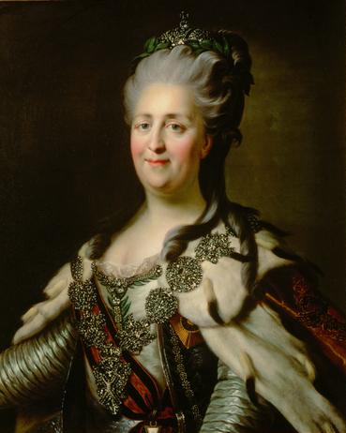
  - In 1786, Catherine II (the Great) sent an agent to invite the Prussian Mennonites to settle in their land.
  - Many benefits were offered:
    - One hundred and sixty-five acres of land
    - Religious freedom
    - Freedom from military service “forever”
- Offer investigated and accepted
  - After two Mennonite men investigated the land and talked to the Russian government about settling in their territory, 228 families left Prussia in 1788 and headed for the Russian province which is now Ukraine.
  - Although they faced many difficult conditions, these families managed to establish a settlement which became known as the Chortitza settlement.
- Life in Russia
  - After Chortitza became established, more and more Mennonites moved to the area and several more communities were established.
  - After some initial struggles, these colonies were quite successful
  - For various reasons, these communities were basically isolated from other groups of people. They formed their own towns and societies, therefore retaining much of their language, culture, and tradition.
- Hardship in Russia
  - In the late 1800s, the Russian Mennonites started to face pressure to join the Russian military, influencing a large group of them (c. 18,000) to emigrate to Canada and the American Midwest
  - In 1917 the Bolshevik Revolution unleashed disaster on the Russian Mennonites
    - Mennonites were caught between the Red Army (Lenin) and the White Army (supporters of the tsar)
    - Nestor Makhno caused the most grief and suffering for the Mennonites—he and his band of outlaws killed, raped, and stole with a fury
    - This kind of suffering was probably harder to bear than the torture that Mennonites had faced during the Reformation and brought them to a crisis in their nonresistant beliefs
      - Some formed self-defense units and were initially successful in providing some protection for their people; later though, they faced horrible revenge from Makhno and the other armies
      - Other Mennonites stuck to their principles and faced the suffering without violence
  - After the Revolution, many Mennonites fled Russia for other parts of the world—22,000 moved to Canada alone.
  - The Mennonites who stayed continue to suffer a lot of harassment, arrest, and banishment from the Communist government
  - At the end of WWII, around 35,000 Mennonites tried to leave Russia and escape to Europe; only 12,000 made it; the rest were forced to return to the Soviet Union; the 12,000 eventually moved to Canada and South America

Add map of eastern Russia, including Ukraine.

