Church History

Mennonites in Russia
- The open door to Russia
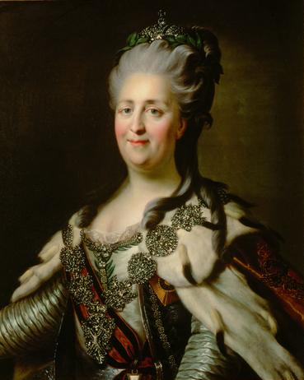
  - In 1786, ___________________ (the Great) sent an agent to invite the Prussian Mennonites to settle in their land.
  - Many benefits were offered:
    - ___________ acres of land
    - ______________ freedom
    - Freedom from military service “_____________”
- Offer investigated and accepted
  - After two Mennonite men investigated the land and talked to the Russian government about settling in their territory, 228 families left Prussia in __________ and headed for the Russian province which is now Ukraine.
  - Although they faced many difficult conditions, these families managed to establish a settlement which became known as the __________________ settlement.
- Life in Russia
  - After Chortitza became established, more and more Mennonites moved to the area and several more communities were established.
  - After some initial struggles, these colonies were quite successful
  - For various reasons, these communities were basically ________________ from other groups of people. They formed their own towns and societies, therefore retaining much of their language, culture, and tradition.
- Hardship in Russia
  - In the late 1800s, the Russian Mennonites started to face pressure to join the Russian military, influencing a large group of them (c. 18,000) to emigrate to ________________ and the ________________________________
  - In 1917 the ______________ Revolution unleashed disaster on the Russian Mennonites
    - Mennonites were caught between the Red Army (____________) and the White Army (supporters of the _________)
    - _________________________ caused the most grief and suffering for the Mennonites—he and his band of outlaws killed, raped, and stole with a fury
    - This kind of suffering was probably harder to bear than the torture that Mennonites had faced during the Reformation and brought them to a crisis in their nonresistant beliefs
      - Some formed ___________________ units and were initially successful in providing some protection for their people; later though, they faced horrible revenge from Makhno and the other armies
      - Other Mennonites stuck to their principles and faced the suffering without violence
  - After the Revolution, many Mennonites fled Russia for other parts of the world—22,000 moved to Canada alone.
  - The Mennonites who stayed continue to suffer a lot of harassment, arrest, and banishment from the Communist government
  - At the end of WWII, around 35,000 Mennonites tried to leave Russia and escape to Europe; only ______________ made it; the rest were forced to return to the Soviet Union; the 12,000 eventually moved to Canada and South America

Add map of eastern Russia, including Ukraine.

