Church History

Menno Simons - A Trustworthy Shepherd (Part 2)
- Minister
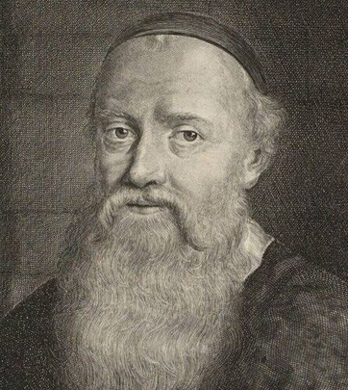
  - A few months after being rebaptized, Menno was ordained to be a minister in the Dutch Anabaptist churches (Obbenites).
  - While Menno felt inadequate for the responsibility, he was greatly concerned for the welfare of the church. He saw a great need for sound teaching and leadership.
  - Throughout the next 25 years, Menno moved around Holland and North Germany, preaching, teaching, baptizing, and discipling.
  - Menno’s success was recognized by civil and religious rulers, who went to great efforts to eradicate him.* However, despite the odds, he survived to die a natural death.
- Writer
  - Along with his preaching and teaching, Menno did a lot of writing. Menno took his motto from I Corinthians 3:11 – “For no one can lay any foundation other than the one already laid, which is Jesus Christ.”
    - Letters of encouragement or advice to church members
    - Booklets which explained the basics of Christianity for believers and non-believers alike
    - Letters to Protestant leaders discussing various points of doctrine
  - Menno’s influence on the church was extended through his writing, even up to the present.
- Leader
  - Menno Simons was an effective leader in the church. In the wake of the Munster tragedy, his solid, trustworthy leadership accomplished much good. One of the most important things that he accomplished was a measure of unification in the Anabaptist churches of this region.
  - The people in these churches eventually became known as the Mennonites. (This name first originated from people outside the church who referred to the Anabaptists in this region as “Mennists” or “Mennonites.”)
(See “Is Menno in the Coach?” dramatic reading and short video clip on Menno with hand drawn pictures)

* Menno had a price of two thousand guilders on his head and those who gave him food or shelter, read any of his books or even spoke with him paid for their kindness with their lives. Tjaard Renicx of Kimswerd for example, was executed in January 1539 for having sheltered Menno. In June 1549 Klaas Jans was executed because Menno had stayed overnight in his house.

