Church History

Menno Simons - A Trustworthy Shepherd (Part 2)
- ____________________
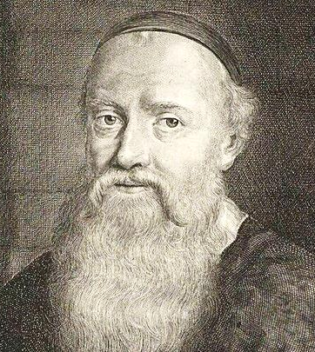
  - A few __________ after being rebaptized, Menno was ordained to be a minister in the Dutch Anabaptist churches (Obbenites).
  - While Menno felt inadequate for the responsibility, he was greatly concerned for the welfare of the church. He saw a great need for sound ______________ and leadership.
  - Throughout the next 25 years, Menno moved around ______________ and ___________________________, preaching, teaching, baptizing, and discipling.
  - Menno’s success was recognized by civil and religious rulers, who went to great efforts to _______________ him.* However, despite the odds, he survived to die a ___________ death.
- _______________
  - Along with his preaching and teaching, Menno did a lot of writing. Menno took his motto from I __________________________: “For no one can lay any foundation other than the one already laid, which is Jesus Christ.”
    - Letters of ____________________ or advice to church members
    - Booklets which explained the ____________ of Christianity for believers and non-believers alike
    - Letters to ____________________ leaders discussing various points of doctrine
  - Menno’s influence on the church was extended through his writing, even up to the present.
- _________________
  - Menno Simons was an _____________ leader in the church. In the wake of the Munster tragedy, his solid, trustworthy leadership accomplished much good. One of the most important things that he accomplished was a measure of _________________ in the Anabaptist churches of this region.
  - The people in these churches eventually became known as the ___________________. (This name first originated from people ____________ the church who referred to the Anabaptists in this region as “Mennists” or “Mennonites.”)

* Menno had a price of two thousand guilders on his head and those who gave him food or shelter, read any of his books or even spoke with him paid for their kindness with their lives. Tjaard Renicx of Kimswerd for example, was executed in January 1539 for having sheltered Menno. In June 1549 Klaas Jans was executed because Menno had stayed overnight in his house.

