Church History

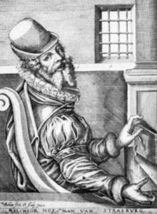
The Münster Misfortune
- Melchior Hoffman - Unbalanced Prophet and omen of trouble
  - Participant in the mainstream Reformation
    - Follower of Luther for a time
    - Licensed to preach by Luther
  - Moved toward a more radical position
  - Became Anabaptist in Strasbourg
  - Because of his unique and strange ideas, he started his own group of Anabaptists
  - Hoffman and his followers were different in the following ways:
    - They were obsessed with apocalypticism, or the events of the End Times.
    - They believed the Spirit spoke directly to people in visions, dreams, and prophecies.
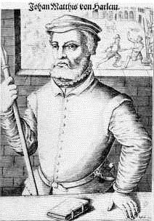
  - Hoffman was very active and successful in missionizing the North German/Dutch area.
- Jan Matthijs - False Prophet and instigator of trouble
  - Convert of Hoffman’s
  - More fanatical than Hoffman
    - Was surrounded by a group of men and women “prophets”
    - Did not believe in nonresistance and non-participation in government
  - Proclaimed that the German city of Münster would be the New Jerusalem and managed to convince many hundreds of Anabaptists, mostly Melchiorites to gather at this place.
  - He and other Anabaptists managed to gain control of the city and organize it into an “Anabaptist City.”
  - All non-Anabaptists were either expelled or forced to accept baptism.
  - Within a short time, Catholic and Protestant forces laid siege to the city.
  - Matthijs was killed by these forces when he left the city walls, expecting to trigger the End Time events.
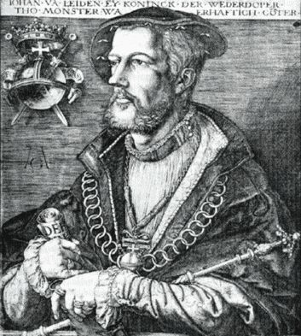
- Jan van Leiden - Evil Prophet and embodiment of trouble
  - After Matthijs was killed, van Leiden, at twenty-four years of age assumed leadership of the city.
  - Even more deluded than Matthijs, van Leiden was proclaimed to be “King over the New Israel and over the whole world.”
  - Under his leadership, all kinds of abominations were instigated.
    - The city was reorganized according to Old Testament pattern.
    - Polygamy was introduced.
    - Dissenters were put to death.
- The Misfortune ends in Disaster
  - After holding out for sixteen months, the situation in the city was desperate, with people starving for lack of food.
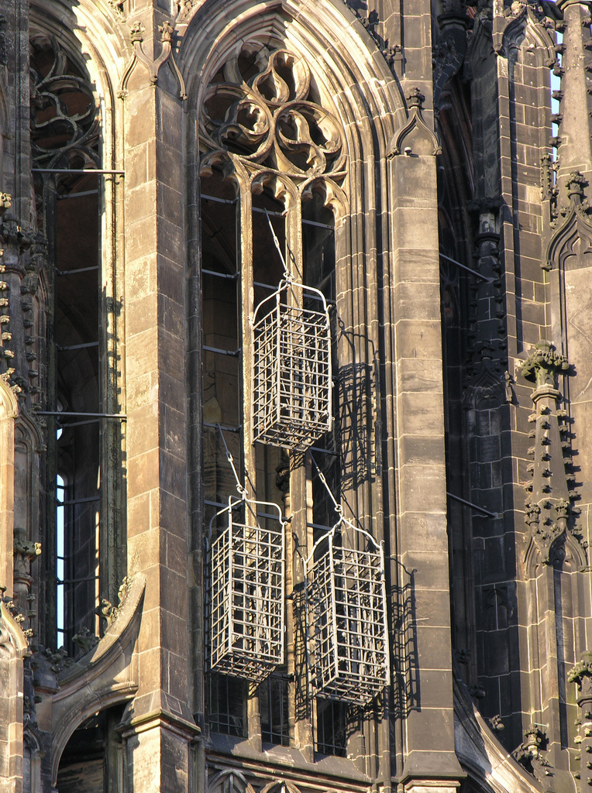
  - Finally, someone inside the city, opened up a door allowing the Catholic and Protestant armies to enter the city. The soldiers laid waste to the city, slaughtering nearly everyone.
  - Jan van Leiden and two other officials were taken alive, persecuted horribly, killed, then hung up in cages in front of a Catholic church as a reminder to all.

