Church History
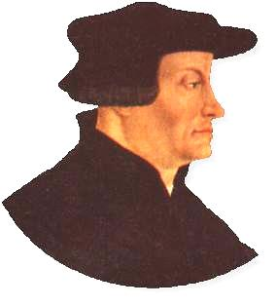
I. A Man Named Ulrich Zwingli
  - Where he lived
    - Swiss Confederation (what is now Switzerland)
    - Zurich (city)
  - When he lived
    - Born in 1484
    - Died in 1531
  - What he believed
    - For the most part, he agreed with Luther
    - He tended to be a little more strict than Luther
    - The biggest difference was his view of the Lord’s Supper
  - What he accomplished
    - Led a reform in the Church in Swiss Conf.
    - This reform led to the development of Protestant districts throughout the Swiss Conf.
    - Contributed to birth of Anabaptism

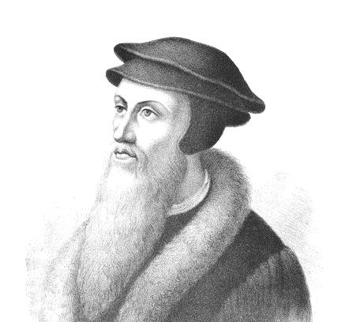
- A Man Named John Calvin
  - Where he lived
    - France
    - Geneva (city)
  - When he lived
    - Born in 1509
    - Died in 1564
  - What he believed
    - Similar to both Luther and Zwingli, but probably closer to Zwingli
    - Differed from both Luther and Zwingli in his view of the Lord’s Supper
  - What he accomplished
    - He led a reform in the city of Geneva which spread all over France and eventually Europe. These churches became known as Reformed churches.
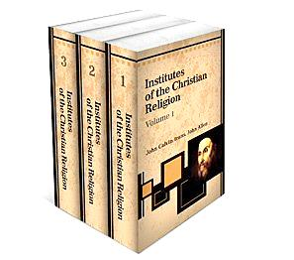
    - He wrote Institutes of the Christian Religion.

